
Volumetric Water Content

How is soil water content relevant?

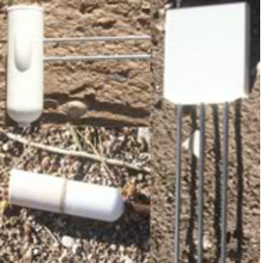
With the development of irrigation based farming, it has become imperative that farmers and agriculturists measure soil water and its effect on plant life. Generally, the soil water content is measured by physically sampling soil and weighing before and after water loss. The mass of water lost while drying is the direct measure of the soil's water content. Determining water content of a soil can also aid in determining the limit at which the soil can retain water. These types of findings may be used to predict a region's response to natural disasters such as droughts or floods.

Studying water content may also aid in water conservation efforts. Once determining the wilting point or the minimum required water level, of a specific crop, agriculturalists can allocate a designated amount of water. This will in return prevent toxic runoffs, field flooding, possible crop and soil dehydration. However, similar practices may be used in ecological restoration efforts.

In soil science, hydrology and agricultural sciences, water content has an important role when it comes to groundwater recharge, agriculture, and soil chemistry. Many recent scientific research efforts have aimed toward a predictive-understanding of water content over space and time. Observations have revealed generally that spatial variance in water content tends to increase as overall wetness increases in semiarid regions. Thus, it decreases as overall wetness increases in humid regions, and peaks under intermediate wetness conditions in temperature regions.

The water content in soils is usually expressed as either a dimensionless ratio of two masses or two volumes, or is given as a ratio of a mass per unit volume. Such dimensionless ratios can be reported either as decimal fractions or percentages, if multiplied by 100. To avoid confusion between the two dimensionless water content ratios, their measurements (i.e., mass or volume) should always be stated.

NevCAN Equipment and Sensors

The Nevada Climate-Ecohydrological Assessment Network (NevCAN) monitors soil water content/stocks (volumetric) by using water matric potential sensors and time domain reflectrometry probes. These sensors are co-located with sap flow and point dendrometer sensors. Collected data is made public on the Nevada Climate Change Portal (NCCP); available as live and archived data.

Volumetric water content is available from sites stationed at the Sheep Range and Snake Range. Sensor data is monitored at the following depths: 24.5 cm (17-32 cm vertical), 20.32 cm (8 in horizontal), 10.16 cm (4 in horizontal) and 9.5 cm (2-17 vertical).

